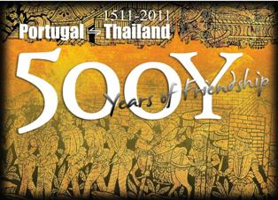
In the Footsteps of the Portuguese:
A Visit to the Portuguese Embassy and Churches in Bangkok
Itinerary: The Embassy of Portugal, the Holy Rosary, Conception and Santa Cruz Churches
Date: Saturday, 25th february 2012

Time | Visit Program
08h30 | - Arrival at the Embassy of Portugal  - Welcome and guided visit to the Chancery led by Aj Luísa Dutra
09H00 | - Walk to the Holy Rosary Church
09H15 | - Arrival and welcome by Father Phaitoon Homjinda  - History of the Church by Ajarn Bidya Sriwattanasarn
10H15 | - Leaving the Harbor Department to Conception Church
10H40 | - Arrival at Conception Church (Wat Rajatiwasviharn Pier)  - Walk to Conception Church  - Welcome and history of the Church by the Community´s representative  - Visit to the Cemetery  - Conclusion by Ajarn Bidya Sriwattanasarn
11H30 | - Leave Conception Church
11H50 | - Arrival at Santa Cruz Church  - Drop by Kanom Farang Confectionery  - Welcome and history of the Church by Father Wittaya Kuwirat and the community´s representative  - Conclusion by Ajarn Bidya Sriwattanasarn  - Lunch of typical food of the community
13:00 | - Back to Taksin Bridge Pier  - History of Ayudhaya by Ajarn Bidya Sriwattanasarn


http://www.facebook.com/#!/500Years.PortugalThailand

