Faculty of Arts
Chulalongkorn University

Attach Photo

Here

Outbound Exchange Student
Application Form
(Non-degree)
Information must be typed.

PERSONAL PROFILE
Mr./Miss/Mrs./Other _______________________________________________________________________
First Name Middle Name Last Name

Name Pronunciation ____________________________________________________________
Sex Male Female Date of Birth _____/________/______
Day Month Year
Nationality ______________________________Passport Number______________________________

Current Address _____________________________________________________________________
Street City __________________________________________________ Tel: _______________________________
State Zip Code Country

Fax: _____________________________ E-Mail: _____________________________________________

Program: International (BALAC) Thai

Proposed field of study: Bachelor Master Ph.D.

Semester in which you wish to enroll: | Before choosing appropriate semester system below, applicants must read the academic calendar  (https://www.reg.chula.ac.th/calendar_en.html)

Semester System
First (Aug-Dec)
Second (Jan-May)
Summer (Jun-Jul)
Academic Year _______

Proposed Grading System:

Standard grading system with A, B, C, D and F
Grading with “S” for Satisfactory or “U” for Unsatisfactory (with examination)
Grading with “V” for Visitor or “W” for withdrawn (without examination)

Universities You Wish to Enroll:
- ______________________________________________________
- ______________________________________________________
- ______________________________________________________

EDUCATIONAL INFORMATION

Home University _________________________________________ Country ___________________

Educational Background

Institution Location Major/Field of study Period of attendance Degree obtained
______________________ _______________ ____________________ ________________ ____________
______________________ _______________ ____________________ ________________ ____________
______________________ _______________ ____________________ ________________ ____________
______________________ _______________ ____________________ ________________ ____________
______________________ _______________ ____________________ ________________ ____________
English Proficiency: (for non-native speaker)
- Have you completed a TOEFL test or equivalent in the last twelve months?
Yes, score:_____________________ No

- Do you intend to sit for a TOEFL test or equivalent in the immediate future?
Yes No

If yes, please provide details of test and date.______________________________________________

- Indicate your English proficiency
Excellent Good Fair Poor
Reading
Writing
Speaking
Listening

Third Language Proficiency: Please specify ___________________
- Have you completed a test in the last twelve months?
Yes, score:_____________________ No

- Do you intend to sit for a test in the immediate future?
Yes No

If yes, please provide details of test and date.______________________________________________

- Indicate your proficiency
Excellent Good Fair Poor
Reading
Writing
Speaking
Listening

Study Plan: (Please use a separate sheet if necessary.)

Faculty: __________________________________________________

Major: ___________________________________________________

_________________________________________________________________________________________
_________________________________________________________________________________________
_________________________________________________________________________________________
_________________________________________________________________________________________
_________________________________________________________________________________________
_________________________________________________________________________________________
_________________________________________________________________________________________
_________________________________________________________________________________________
_________________________________________________________________________________________
_________________________________________________________________________________________
_________________________________________________________________________________________
_________________________________________________________________________________________
_________________________________________________________________________________________
_________________________________________________________________________________________
_________________________________________________________________________________________
_________________________________________________________________________________________
_________________________________________________________________________________________
_________________________________________________________________________________________
_________________________________________________________________________________________
_________________________________________________________________________________________
_________________________________________________________________________________________
_________________________________________________________________________________________
_________________________________________________________________________________________
_________________________________________________________________________________________
_________________________________________________________________________________________

Please check that you have enclosed all the relevant documents with your application:

- A completed application form
- 2 references in signed and submit the sealed envelopes at the Dean’s Office (if any)
Dean’s Office Address: Room 119 Mahavajiravudh Building
Faculty of Arts, Chulalongkorn University
- An up-to-date transcript of academic records
- An English proficiency score record (for non-native speaker of English) (if any)
- A copy of your passport
- Study plan / description of academic interests
- An 1-inch-colored photo taken no more than six months in polite attire or a civil servant’s uniform, attached to the application form

Submit the sealed envelopes of 2 references in signed at the Dean’s Office:

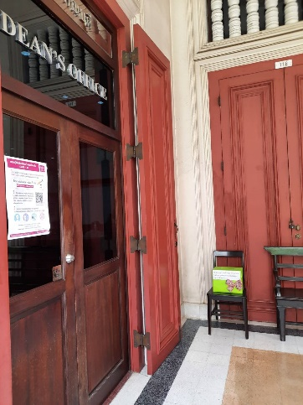
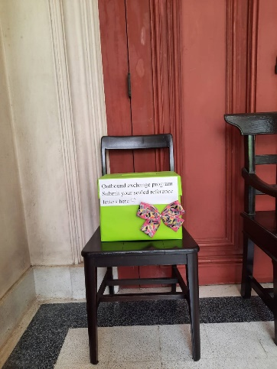

STUDENT’S SIGNATURE

I hereby apply for admission to study at Faculty of Arts, Chulalongkorn University and I confirm that the information provided above is correct to the best of my knowledge.

Signature _________________________________________________ Date ___________________________

---------------------------------------------------------------------------------------------------------------------------------

