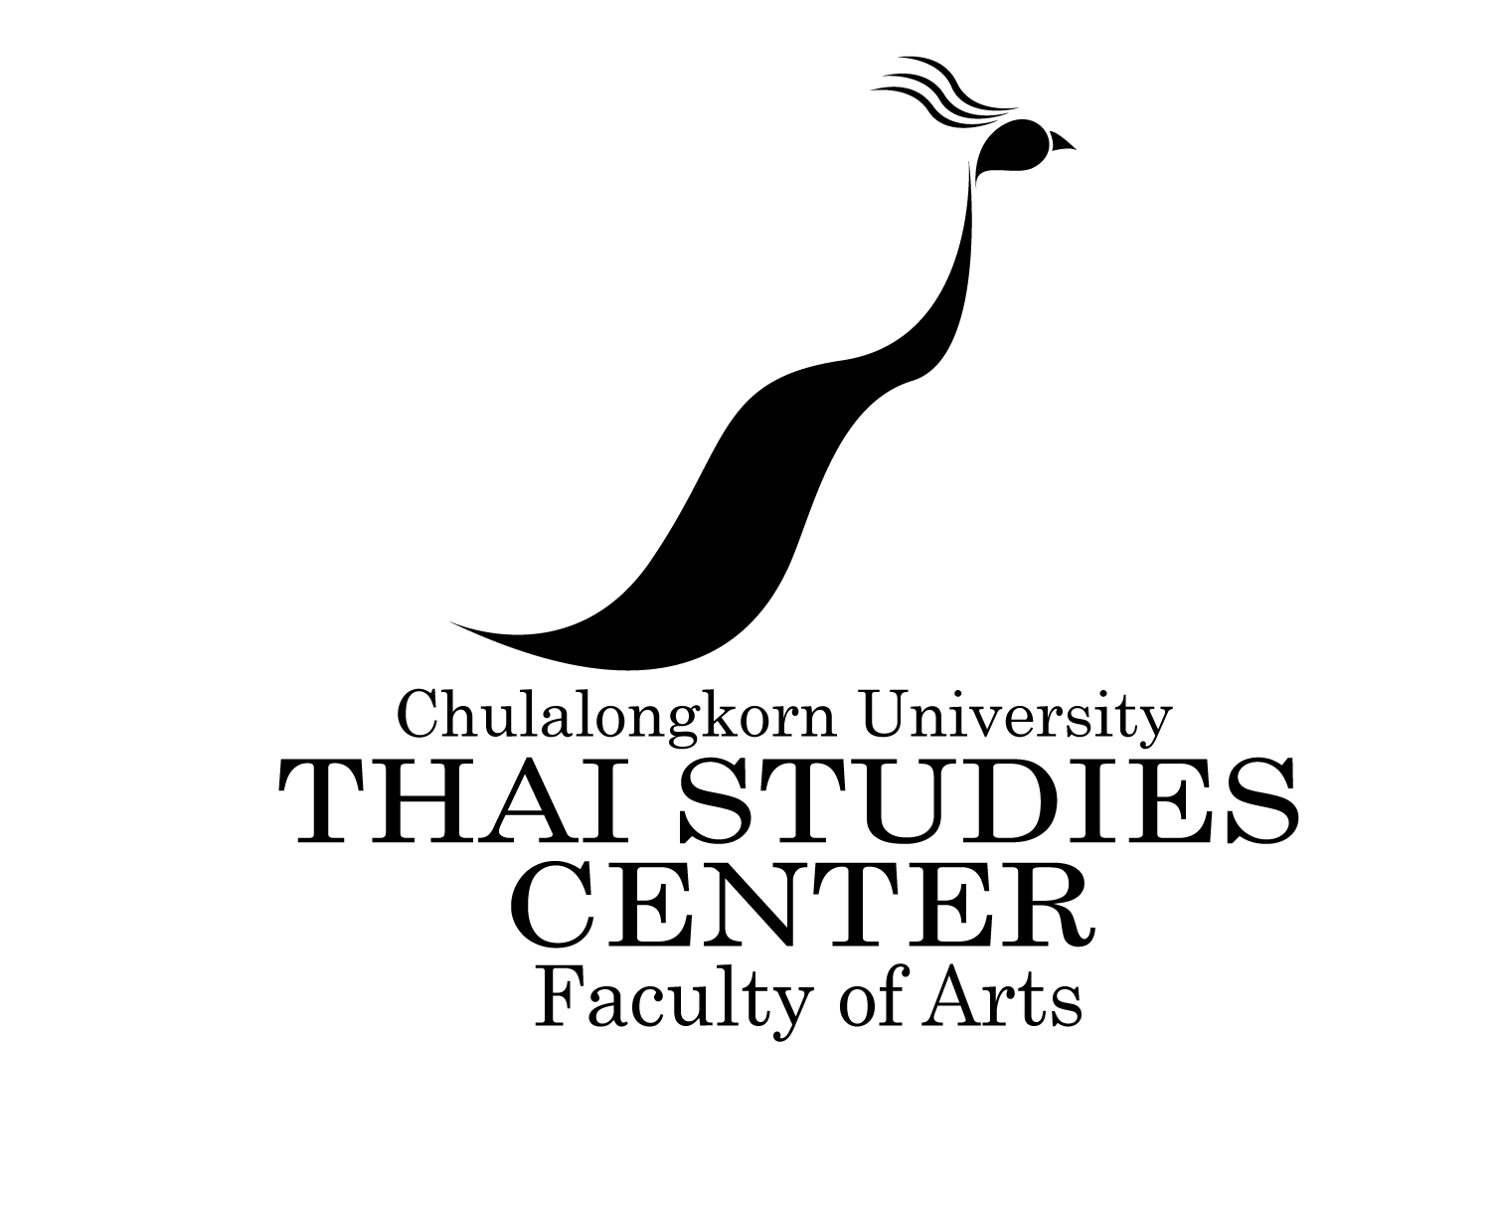
Thai Studies Center,
Faculty of Arts, Chulalongkorn University,
Bangkok 10330, Thailand
Tel: (662) 218-4530-1
E-mail: thaistudies_chula@hotmail.com

APPLICATION FORM

MASTER’S DEGREE IN THAI STUDIES
Plan of Study: Plan A (Thesis Program)
Plan B (Non-Thesis Program)

For First Semester Second Semester Academic Year…………

Required qualifications

- Applicants must possess a Bachelor’s Degree in any field from Thai or foreign universities with a GPA of not lower than 3.00 (Maximum GPA of 4.00)
- Applicants must have a good command of English

Required documents

Applicants are required to submit following documents

- A completed application form with a photograph (3cm x 4 cm) attached
- A copy of Bachelor’s Degree certificate
- A copy of academic transcripts (in English)
- Curriculum Vitae
- Two recommendation letters from dean, head of department or advisor of the applicants’ institution
- Any of the following English Proficiency test result:
- CU-TEP (≥45) OR
- TOEFL (Paper-based ≥450, Computer-based≥133, Internet-based ≥45-46) OR
- IELTS (≥4.0)
- Brief research proposal for Plan A or statement of purpose for Plan B
- A copy of Thai National ID card (for Thai applicants only)
- A copy of passport (for foreign applicants)

1. Personal information
Title: Mr. Mrs. Ms. Other: ____________________________
Name: ___________________________ Middle name: __________________
Surname: ________________________
Name spelling in Thai (if applicable)
คำนำหน้า นาย นาง นางสาว อื่น ๆ ระบุ __________________________
ชื่อ _________________________ ชื่อกลาง __________________________
นามสกุล ______________________

Mailing Address: (In case of changes, please notify immediately)
________________________________________________________________________________________________________________________________________________________________________________________________________________________

Telephone ______________________________

Fax ______________________________

E-mail ______________________________

Birthdate ____________ ___ Age ___________Place of Birth________ ______
(date/month/year)
Native Language_____________ _______Citizenship_ __

Marital Status______________________ Passport Number______________________

2. Do you plan to live on campus? [ ] Yes [ ] No
Please state how you will meet the full expenses at your course.
If from scholarship, give name, duration, value and state if award has been made:
________________________________________________________________________________________________________________________________________________

3. If you are now a candidate for a degree, please state the following:
Degree__________________________ Major _______________________________
Expected date of completion ____________________________________________
Institution ______________________________ City _________________________

4. Current employment and status:
[ ] government employee [ ] non-government employee [ ] unemployed
Name of institution/office/company________________________________________
Address_______________________________________________________________________________________________________________________________________
Telephone __________________ Fax________________
E-mail _________________________________________
Position and responsibility
________________________________________________________________________________________________________________________________________________________________________________________________________________________________________________________________________________________________

5. Knowledge of English and Thai (good/fair/poor)

Speaking Writing Reading
English _______ ______ _______
Thai _______ ______ _______
Other language apart from
your native language (if any) _______ ______ _______

6. Education and training:

Education | Name of institute, city | Years of study | Name of the degree | GPA
Senior  High School |  | to  to
Graduate |  | to  to
Post  Graduate |  | to  to
Training |  | to  to  to

7. Field of specialization
Major_____________________________________ _
Minor _________________________________________

8. I hereby certify that the information I have given in this application is complete and accurate. I agree that upon admission I will subject to the rules and regulations of Chulalongkorn University.

Signature of applicant _____________________________ Date__________________

Signature of sponsor ______________________________ Date__________________

Additional Information

1. Have you attended any training programs on the Thai language?
________________________________________________________________________________________________________________________________________________________________________________________________________________________

2. How did you learn of the Thai Studies Centre at Chulalongkorn University?

[ ] alumnus [ ] advisor or instructor [ ] others______________________

Have you ever applied for admission to Chulalongkorn University?

[ ] No [ ] Yes, Year_________

3. Have you had previous personal contact with a University representative?

[ ] No [ ] Yes, With whom?__________________ When? _______________

4. Have you ever been to Thailand? [ ] Yes [ ] No

If yes, please specify the dates and purpose of visit(s).

During the period of _________________ for (purpose) ________________________

During the period of _________________ for (purpose) ________________________

Details of Spouse or Dependants: Do you have a husband/wife or any dependants?

(a) Already in Thailand [ ] Yes [ ] No

(b) Intending to accompany or join you in Thailand? [ ] Yes [ ] No

5. If yes to either (a) or (b) please complete details below:

Last Name | First Name | Relationship | Date of  Birth | Will dependent study in Thailand? |  | Institution
 |  |  |  | Yes | No

